МИНИСТЕРСТВО НАУКИ И ВЫСШЕГО ОБРАЗОВАНИЯ  
РОССИЙСКОЙ ФЕДЕРАЦИИ

федеральное государственное автономное   
образовательное учреждение высшего образования  
«Самарский национальный исследовательский университет   
имени академика С.П. Королева»

(Самарский университет)

Институт информатики, математики и электроники

Факультет информатики  
Кафедра суперкомпьютеров и общей информатики

**Отчет по лабораторным работам № 6**

Дисциплина: «Enterprise Systems Development (Методы проектирования и поддержки требований к программному обеспечению)»

Тип предприятия: **«Social Network»**

Тема: **« Business process implementation»**

Выполнила: Курбатова О.В.

Группа: 6133-010402D

Самара 2021

# Assignment # 6 Business process implementation

Objective: To study the business process implementation with Cuba Platform

## Tasks

1. Create Cuba Platform project, which will implement one of business processes of previously selected organization.
2. Add section to doc report image, which should include:

* Selected business process description (several sentences). It is desirable that the business process be the same as business process described in assignment #4.
* Instructions for running the application, prerequisites.
* Step-by-step instruction with demonstration of business process automation using the application.

1. Send zipped Cuba Project files and doc report to j-avdeev@yandex.ru

## Notice

Use Cuba Platform documentation (for example <https://doc.cuba-platform.com/bpm-latest/bpm.html> or <https://doc.cuba-platform.com/bpm-latest-ru/bpm.html> (on Russian)).

Yes, can use your preferable framework (not Cuba Platform) to create a web application to automate chosen business process.

**Assignment #6.** Business process implementation

**Task 1-2**

I had developed an application using common Spring architecture and technologies. The application has three layers (data, logic, view) and provides means to work with a database.

I had developed Develop a REST API for accessing my data. It allows usage JSON.

I used Gradle to manage my project.

As a result, a prototype of the application was developed, which provides the ability to log into a social network using Google authorization, write, delete, edit text messages.

The start page is shown in figure 1

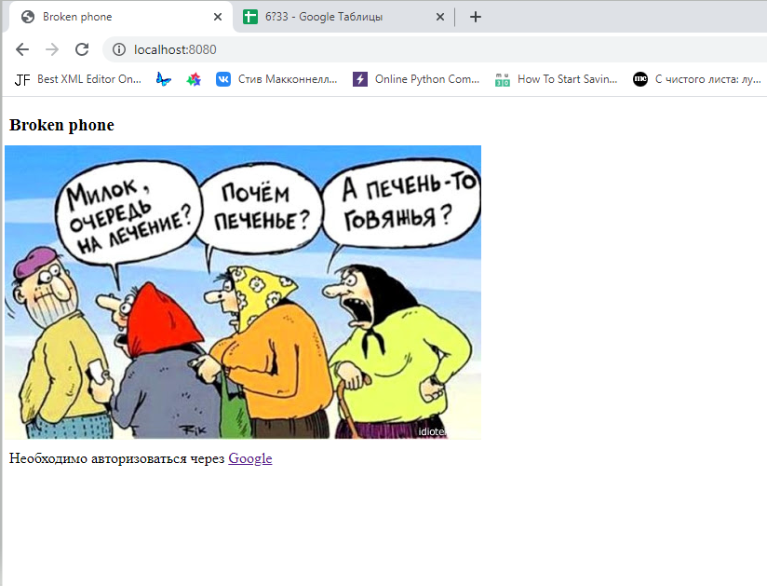

Figure 1 – Broken Phone web-app start page

Then click Google authorization link and see authorization form (fig.2a and 2b)

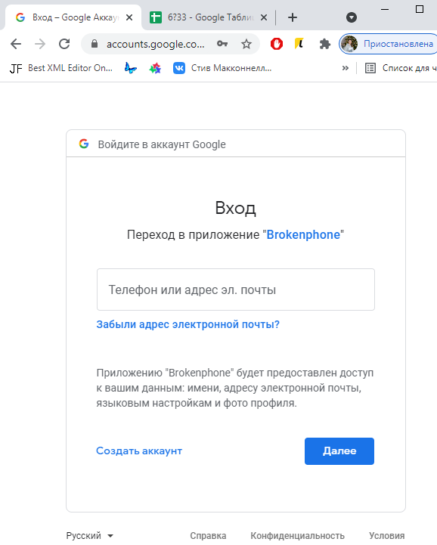

Figure 2a – First Authorization - Google form

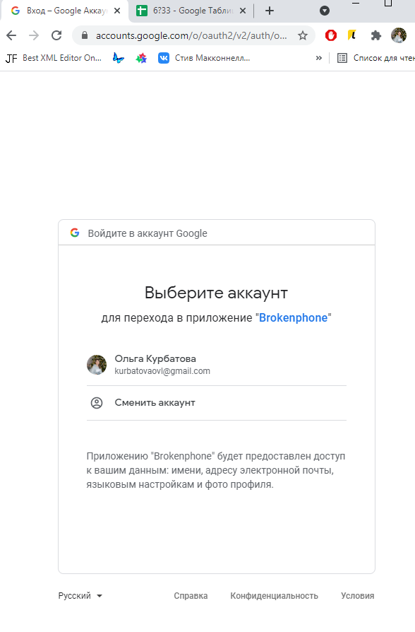

Figure 2 b – Second (and other) Google Authorization form

Check User registration on DataBase

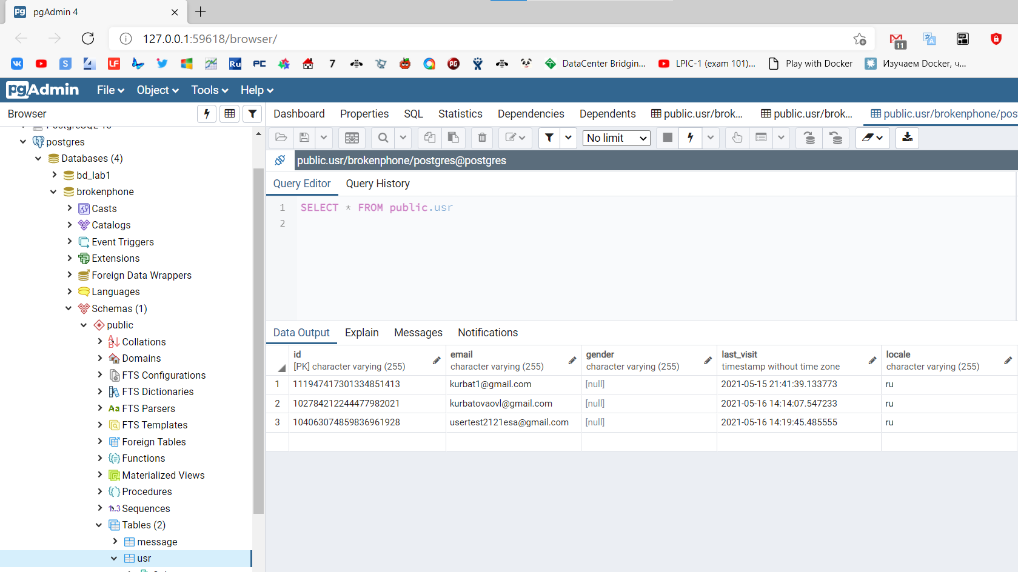

Figure 3 – Data Base Scrin – Table “Usr”

After Autorization we see authorized page with text messages

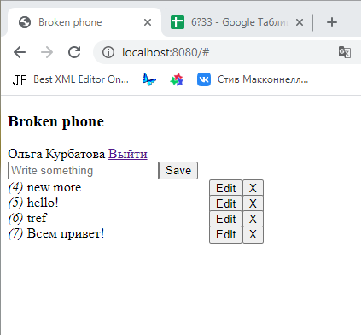

Figure 4 – Authorized page

In the message input field, write "Hello everyone!” (fig.5a)

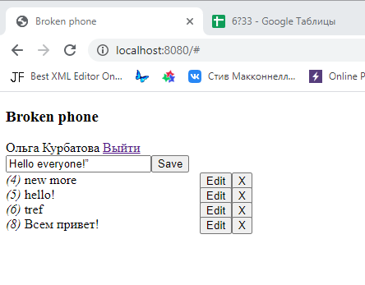

Figure 5a – Message input

and press the «save» button! (fig.5b)

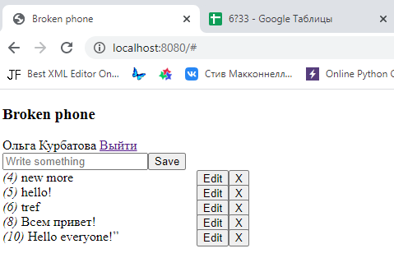

Figure 5a – Message was saved

Let’s delete message number 4. Press delete button “X”(fig,6)

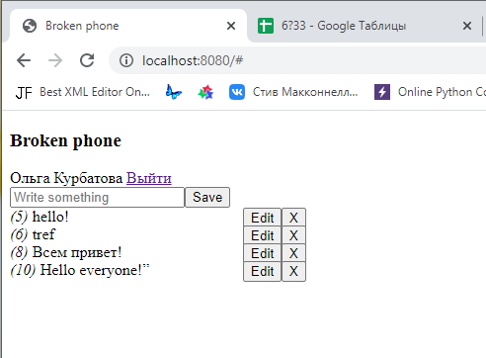

Figure 6 – Message was deleted

Check on DataBase(fig.7)

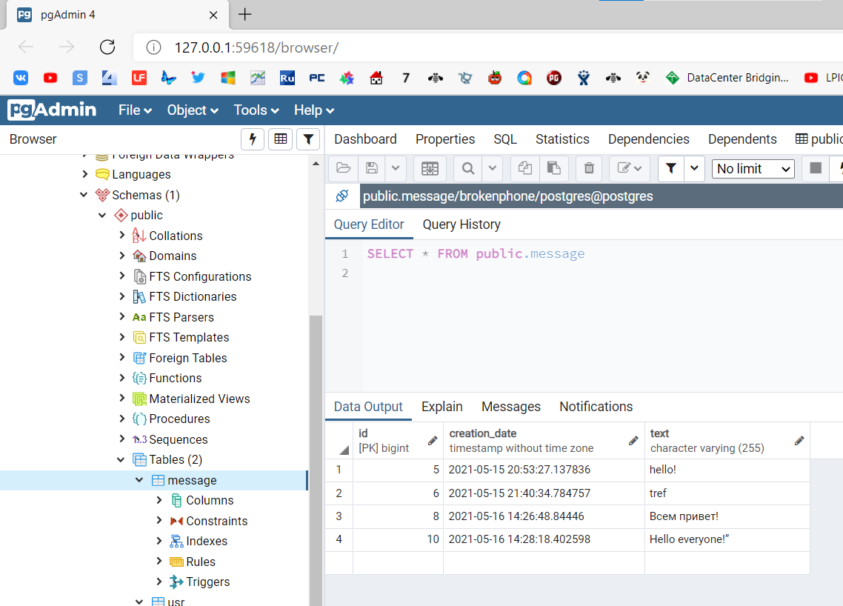

Figure 7 – Data Base Scrin – Table “Message”

Let’s Edit last message(fig.8 a), press “Edit” button

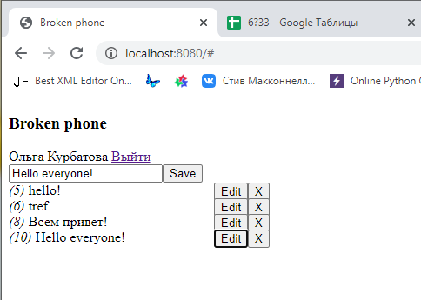

Figure 8a – Edit message

And press Save button

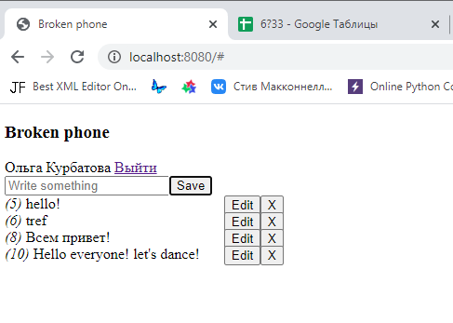

Figure 8a – Edited message was saved.

Then we exit the application, press the "Exit" button and return the start page.

**Conclusion**

In the course of the work, the skills of developing web applications were acquired based on the previously done analysis using technologies such as Spring, Gradle, DataBase PostgreSQL. As a result of development, a prototype of a web application was obtained.

The project was published on github <https://github.com/kurbatovaolga/BrokenPhone>